Project Report

Object Oriented Design and Programming with Java

19CS3503

Student Online Voting System

‘

|  |  |
| --- | --- |
| **ENG19CS0059** | **B.Vijay Kumar Kakra** |
| **ENG19CS0085** | **Dheeraj Kumar** |

**Faculty: Dr. Neelam Bawane**

**Content from ppt presented during 1st presentation.**

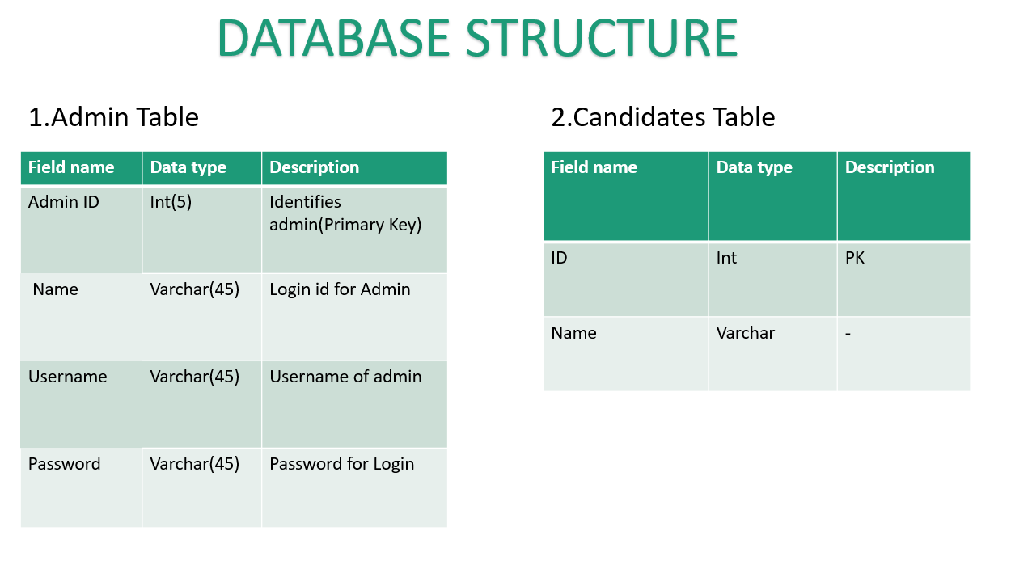

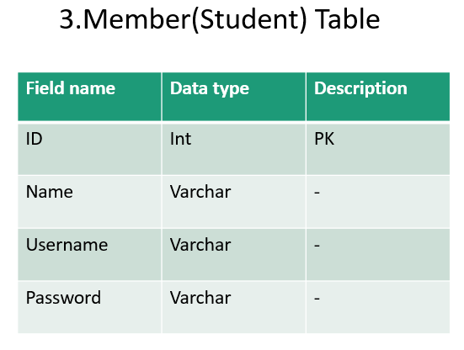

**Project functionalities: -**

* It’s a web-based application developed on Java using JavaFX, IntelliJ idea and MYSQL.
* The core functionality of the application is to perform voting between 2 or more than two parties.
* Users can vote according to there interest to there respective candidate.
* Admin can check the result and announce the result at the end of the election.

**Connection code snippet**

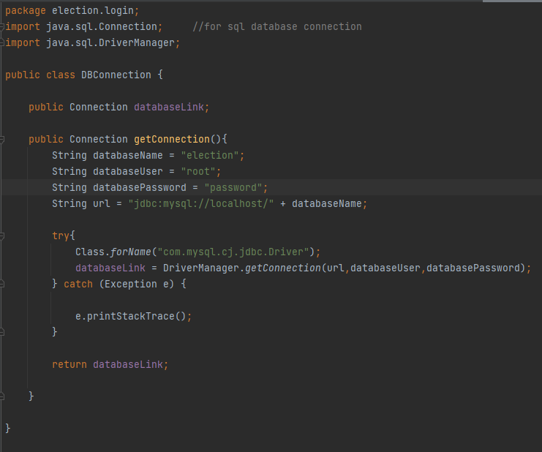

**Insert record code snippet**

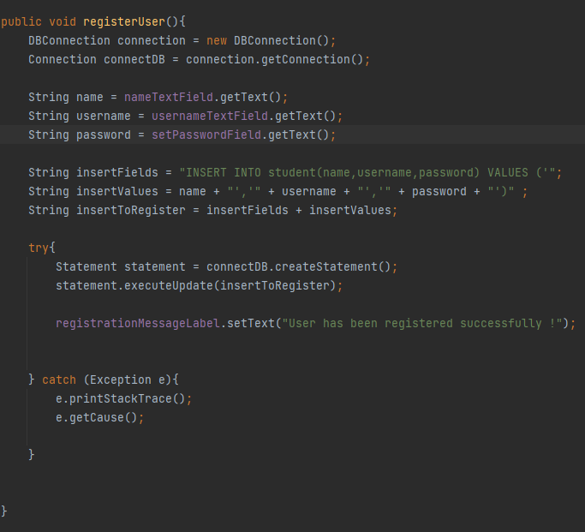

**5-6 Screen shots - demonstrated during 2nd demo**

**1.Homepage.**

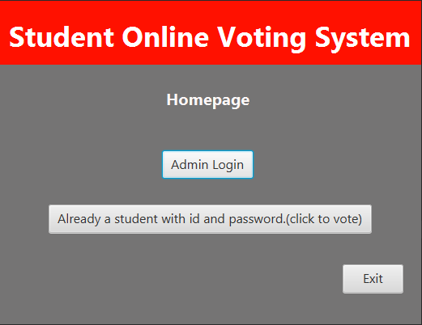

**2.Admin login page**

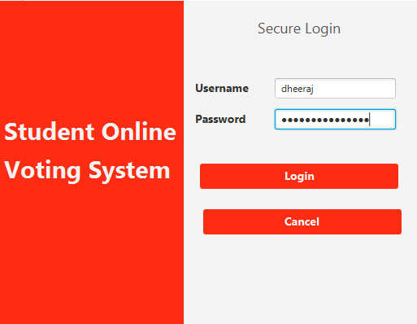

**3.Registering a user(student) through admin.**

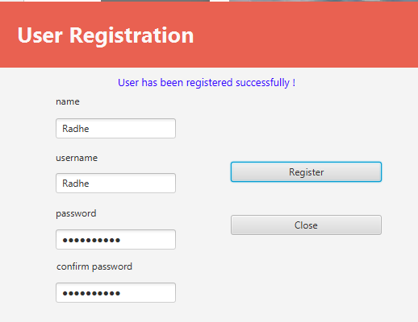

**4.Showing that the registered user “hasn’t voted yet” in the database student table.**

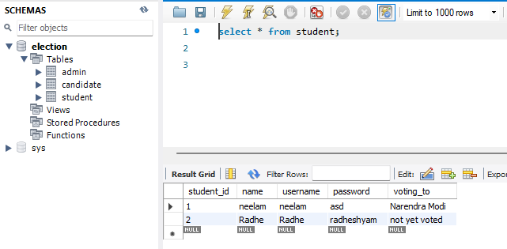

**5.Logging in with the registered username and password.**

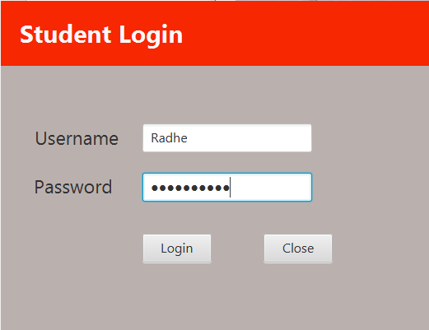

**6.Voting to the candidate.**

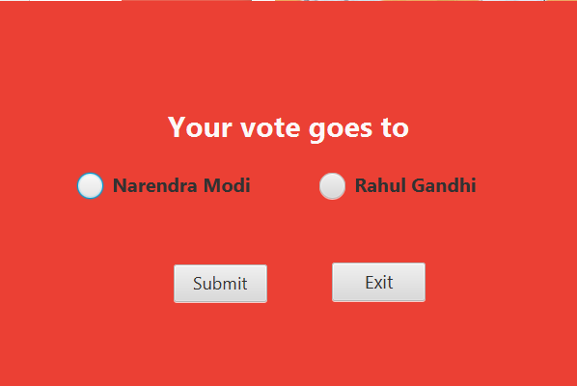

**7.Displaying that the vote has been updated in the database.**

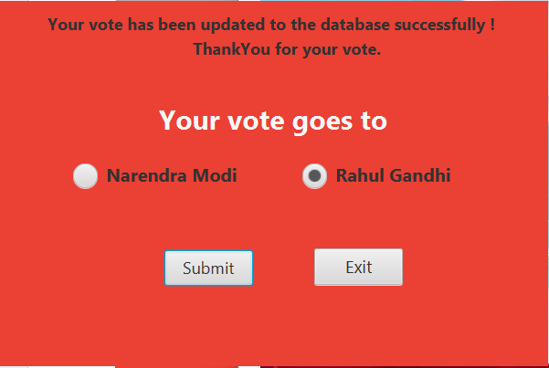

**8.Checking it in the table ‘student’ for the student’s vote. And hence successfully voted for the candidate.**

